1. FIRST PAGE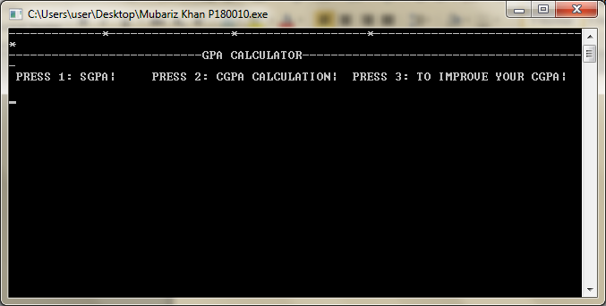PL
2. The second page is the execution of the sgpa class.
3. The second page is the execution of the sgpa class 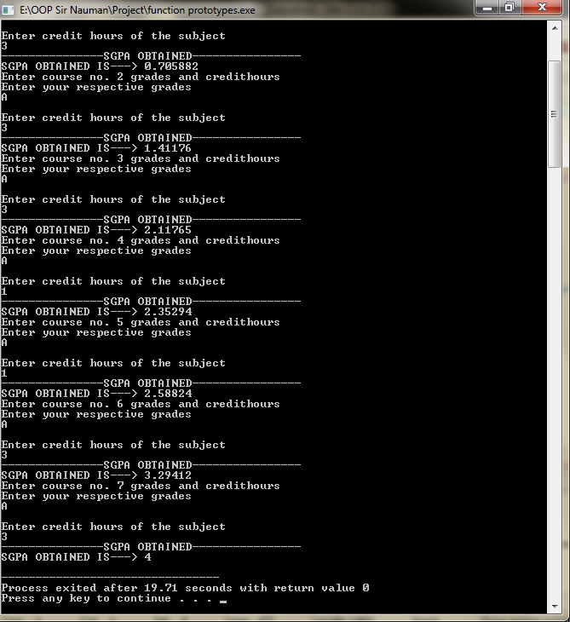 th

Execution of CGPA class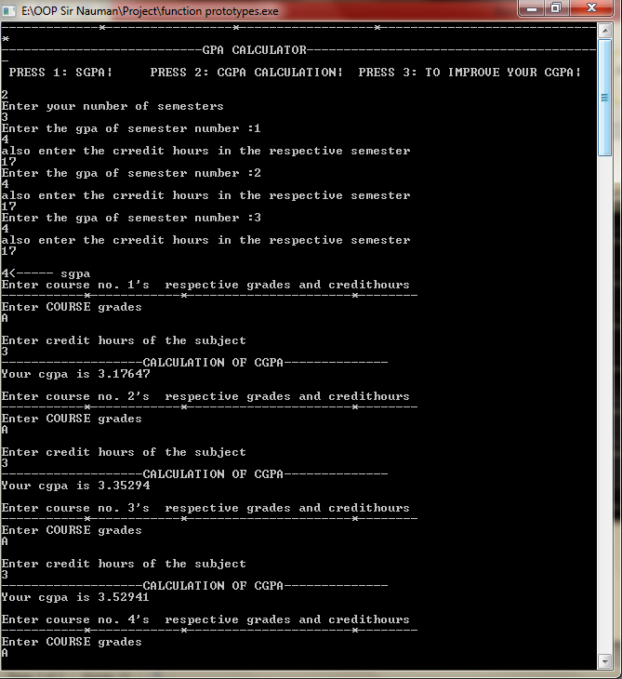the output of cgpa class 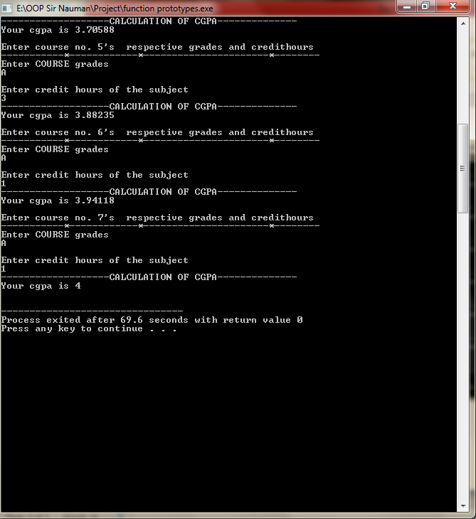this page is the execution of cgpa class, the next page is the improve cgpa class.

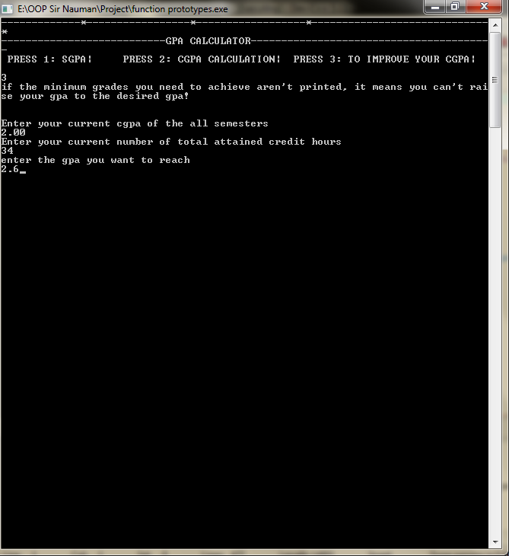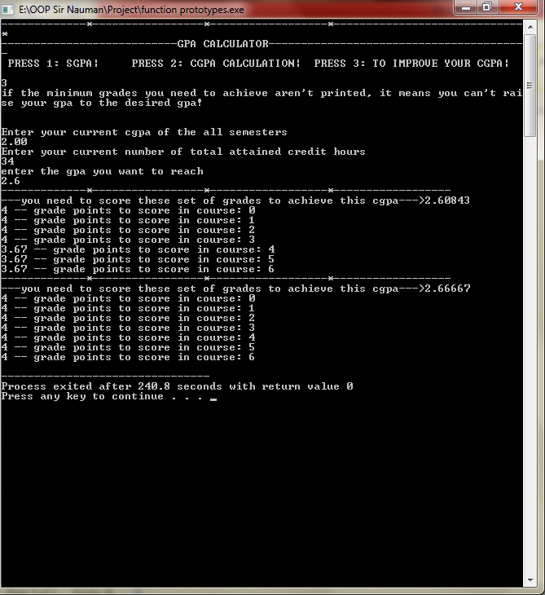 this is the improve cgpa class.